HOW TO TAKE YOUR IMPRESSION
PREPARATION
BEFORE YOU BEGIN: Wash your hands and try both trays for size. Ensure that you choose the right sized trays: all your teeth should comfortably fit the tray, without hitting the sides of the tray.
WHEN TAKING IMPRESSION: Ensure putty is mixed well, there should be no white/blue streaks, work quickly as the putty will start to set in 20 seconds. Hold the impression tray in your mouth for 2 minutes ensuring that the putty covers your gum line, do not try to talk or move. To remove the tray slowly wiggle it out DO NOT PULL IT STRAIGHT OUT!
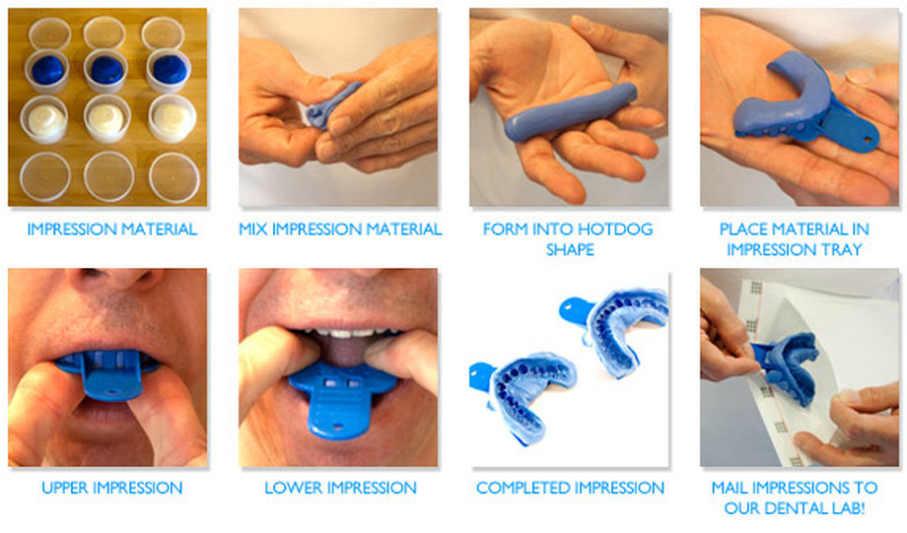

Once completed send us a picture for us to inspect then please return to:
17 Jewellers
FLAT 46, ROOM 1
1Q PENWORKS HOUSE, 5 MOLAND STREET
BIRMINGHAM
B4 7AS
PLEASE RETURN ANY UNUSED IMPRESSION TRAYS
You are responsible for return postage, it’s recommended that you send your impression using royal mail 1st Class Signed For as its trackable!

